**LAB ASSIGNMENT 2**

**PYTHON AND DEEP LEARNING**

**Author:**

Harika adivanne

Class id: 02

**Objective:**

The Key objective is to focus on all the python basics and to execute better code with zero defects and reach the expected output.

**Features:**

* Proper indentation
* Easy understanding
* Loops
* Usage of inbuilt keywords
* Arithmetic operations
* Init constructor
* Lists
* Inheritance concepts like Single and Multiple inheritance
* Use of Private data member
* Super call function

**Configuration:**

* IDE: PycharmCE2017
* LANGUAGE: Python 3

**INPUT/OUTPUT:**

1. **BOOK DICTIONARY:**

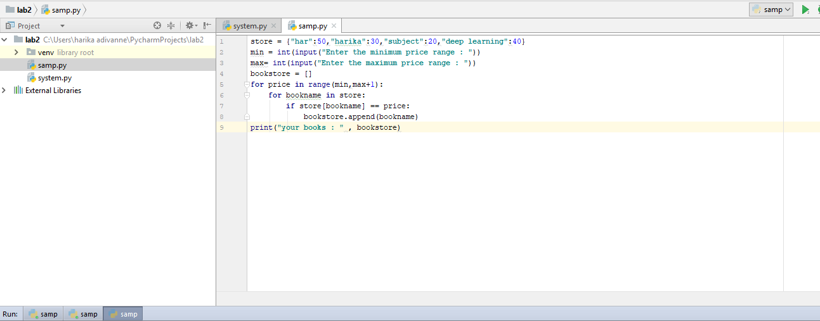

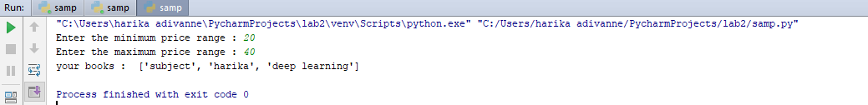

**IMPLEMENTATION:**

Initially created a list for books and its range and set the input entry for minimum and maximum values. Created an empty list where the loop will be iterated for checking the minimum and maximum range and display the book names in the selected range.

2. Contact List:

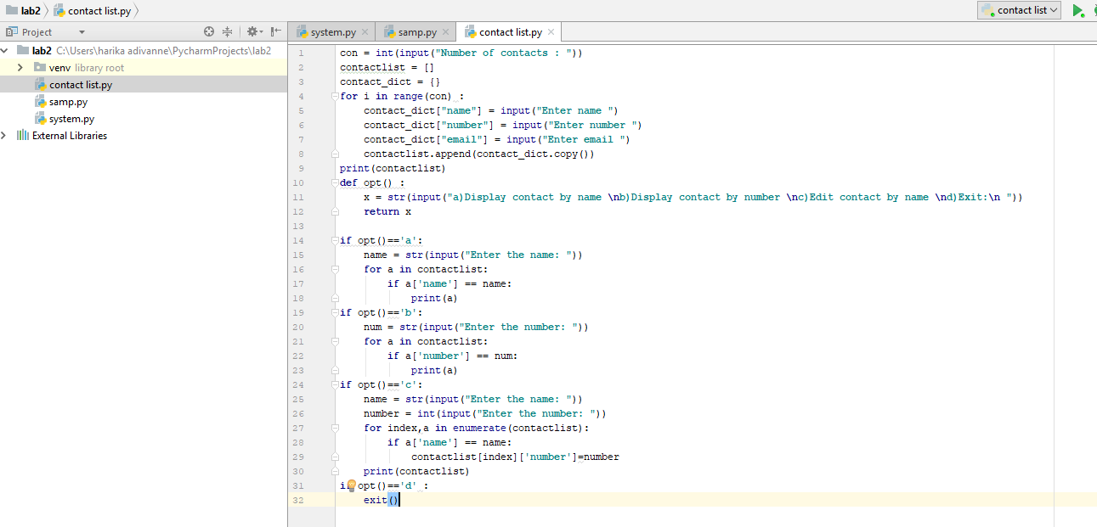

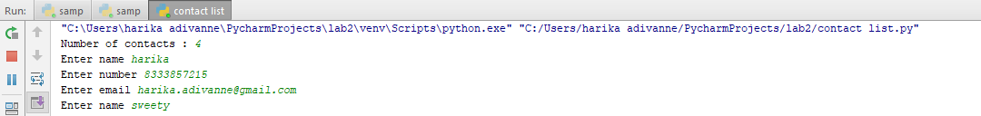

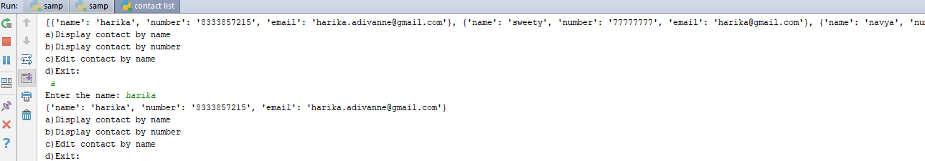

**Implementation:**

Initially created two empty lists for contact list and dictionary (used the iterative loop) where user can enter the contact name, number and email id and print the contact list. Using the if condition loop by providing the options it displays the name, number or email id.

**3. Student Enrollment System:**

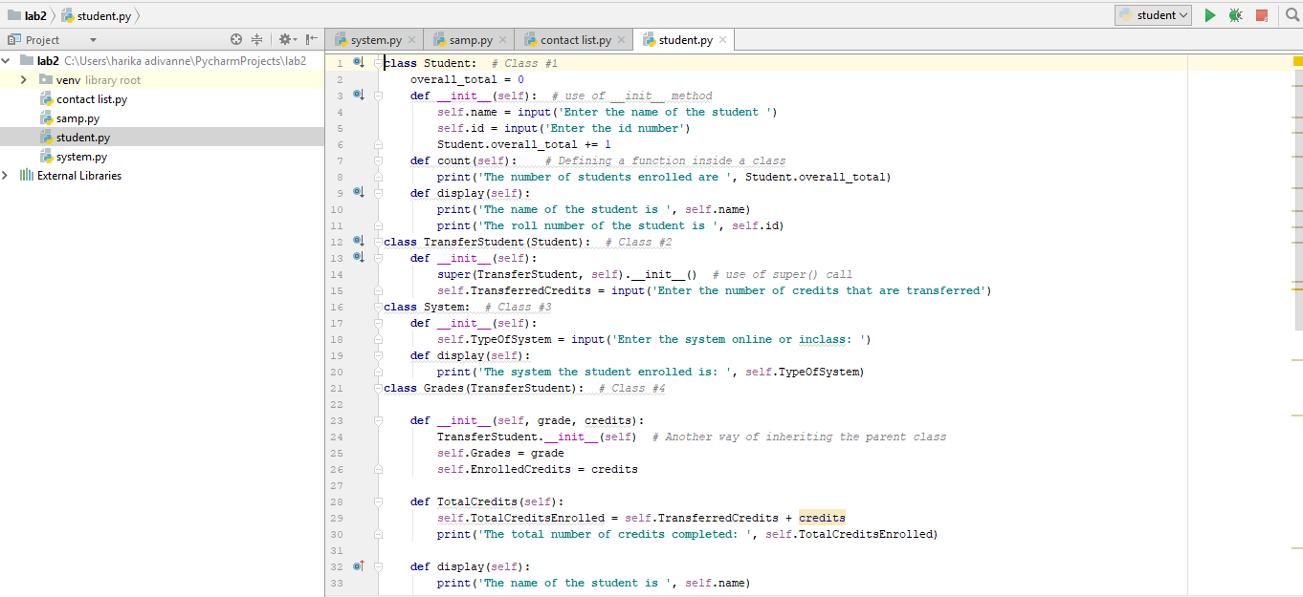

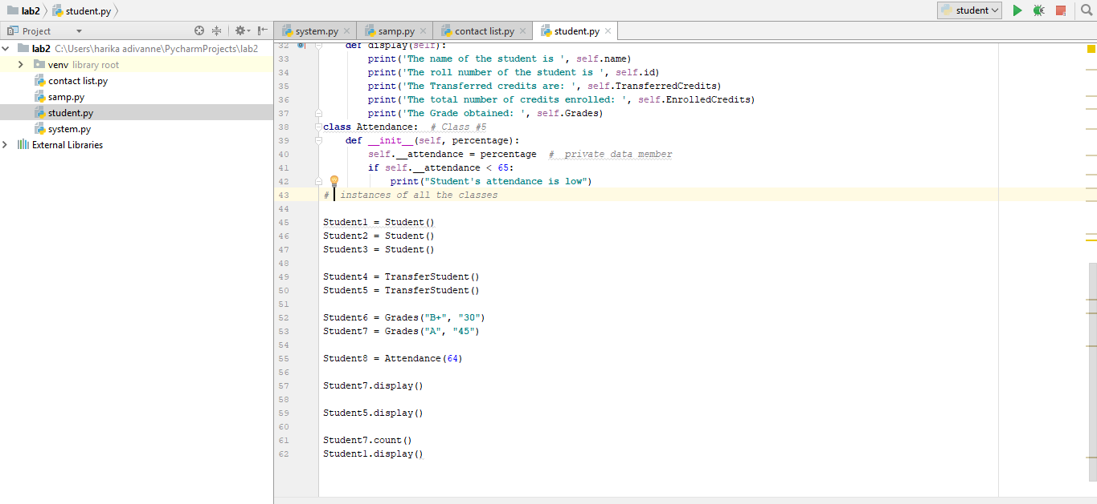

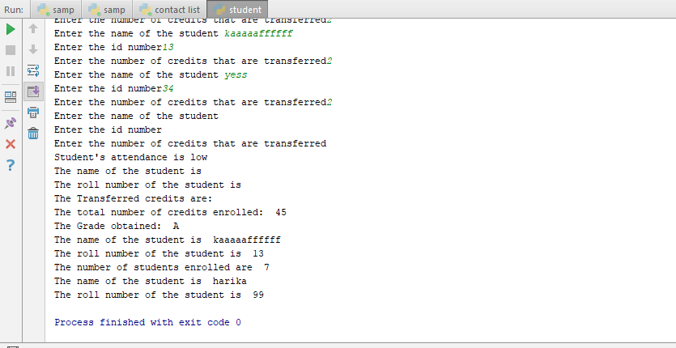

Implementation:

Here I have created five classes for student enrollment system where I have declared functions using init constructor and also used self in the functions and created instances for all the objects and also implemented inheritance by using base class Student and included super keyword function so that students details can be entered by user and based on the credit score the results will be displayed.

4.numpy vector:

